Hardware: Communications
hw_communications.php — Hardware

Communication


'Talking' to other computers - and other people
The ability of computers to communicate has become a vital part of what they do. It is what has made computing devices an essential everyday tool for most people.
Communication has become an essential part of the IPO Cycle and often computers fetch data / instructions from other computers, process the data and then send the results off to another computer without any human involvement.
Use the dropdowns below to explore the hardware used to make communication possible.
Communications in Mobile Devices

The communications controllers in mobile devices are most often built into the SoC.
The only external hardware is the antennas used to send / receive radio signals for cellular, Bluetooth or WiFi communication.
Mobile devices usually include:
- Bluetooth
- WiFi
- Cellular
communications technologies.
These are all radio based technologies because their very design means that these devices are not suitable for connecting to physical media such as ethernet cables.
Communications in Laptops
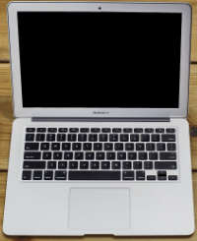
The communications controllers in laptops are most often built into the motherboard.
Laptops usually include:
- Bluetooth
- WiFi
- an RJ-45 ethernet port
communications technologies.
There is a trend for smaller, thinner laptops not to include an ethernet port - but you can easily add one by buying an Ethernet USB dongle.
Communications in Desktop Computers
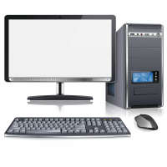
The communications controllers in desktop computers are most often built into the motherboard.
Desktop computers usually include:
- WiFi
- one or more RJ-45 ethernet ports
communications technologies.
Apple desktops include Bluetooth and so do some PC models. Bluetooth can easily be added by buying a Bluetooth USB dongle.
Connecting to the internet
This is discussed in much more detail in the Internet module, but we will summarise these communications options here.
No matter what device you are using you will need the following to connect to the internet:
- An ISP:
The ISP will provide you with data.
- A connection medium:
This will be either Fibre Optic cable, ADSL / VDSL over a telephone line or Cellular connectivity using your smartphone, tablet or a Cellular dongle / router.
- A Router:
This is the device that connects to the medium (Fibre, Telephone line or Cellular radio) on the one side and creates either a WiFi or wired network (or both) that your computing devices can connect to. Once your devices connect to the local network created by the router, your devices can connect to the internet.
The exception is mobile devices because they can use their own cellular radios to connect to the internet directly.
Mobile devices can also be used to create a WiFi network which a laptop / desktop can connect to so as to share the mobile device's internet connection. In this case the mobile device is doing the job of a router.

Video Links - Hardware: Communications
We have selected and curated a set of videos on YouTube related to your course.
These videos are not created or owned by us.
They may display advertising and in some cases may contain limited amounts of swearing.

